Nathaniel Williams

CIS355 Business Application Course Project

User Manual

Upon opening the Lawn Service Program, you will be introduced to an Order Form. Fill out the blanks with the appropriate information, ensuring that you provide input for all fields, then press ‘Place Order’ to process the order to the ‘Receipt’ tab, or press the ‘Clear’ button if you wish to clear all information and start over. NOTE: It is important that you fill in the information from top to bottom. Starting with Client Name and progressing down from there. Failure to do so will promote an error message that will inform you to fill in the missing information.

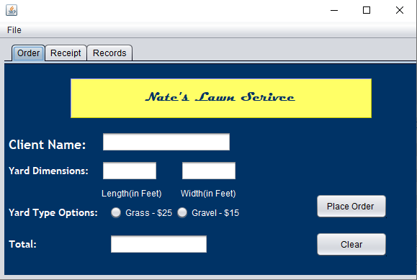

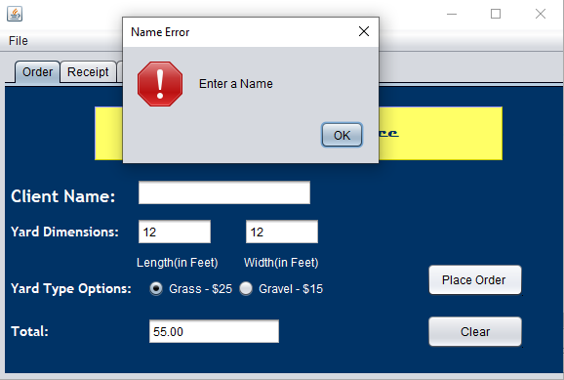

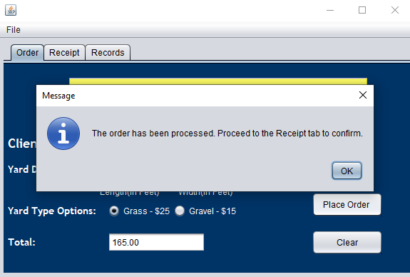

Once at the Receipt tab, you will be introduced to an overview of the information you input, your total, and three buttons. Select the ‘Confirm’ button if you are satisfied with information you have provided or ‘Modify’ to be prompted to return to the Order tab and provide different information.

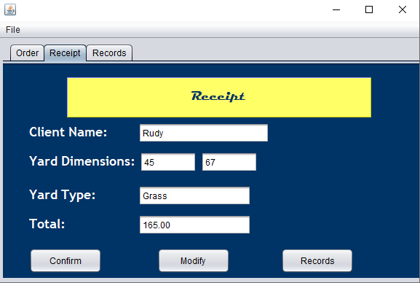

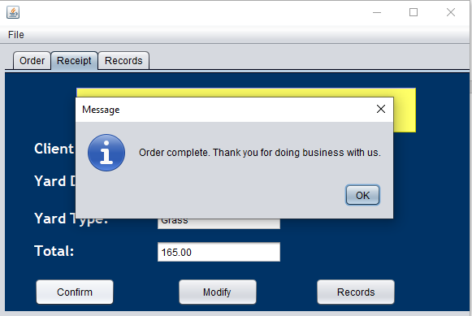

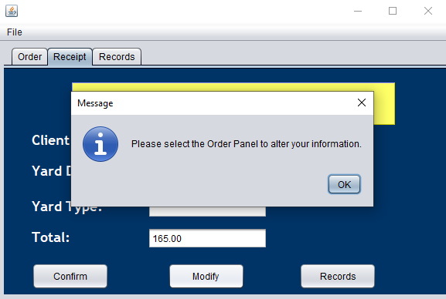

Selecting the ‘Records’ button will prompt you to select the Records Tab. Here, pending/previous jobs are showcased. 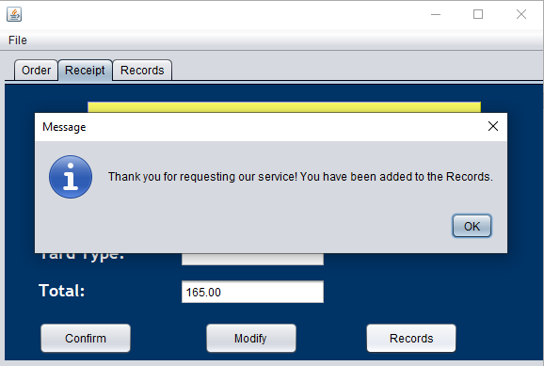

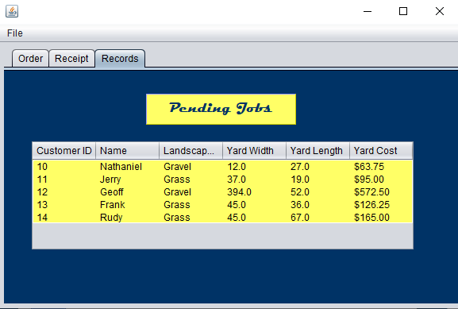

To exit the program, select ‘File’ on the toolbar and select the ‘Exit’ menu Item.

